Freshwater Mapping Protocol

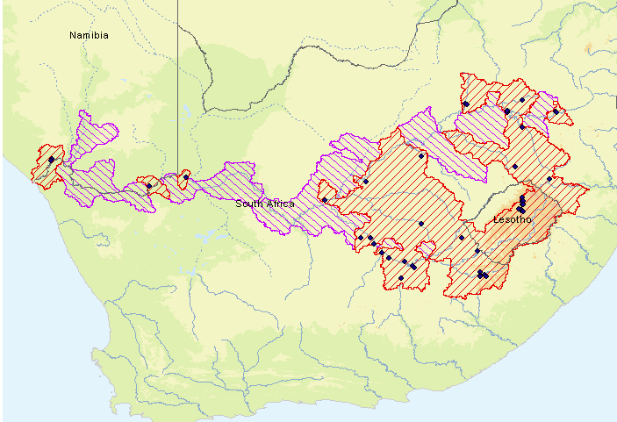

A key part of the IUCN Red List assessment is a species distribution map. Freshwater species are mapped to river basins. A global dataset of river basins known as HydroSheds can be downloaded here.
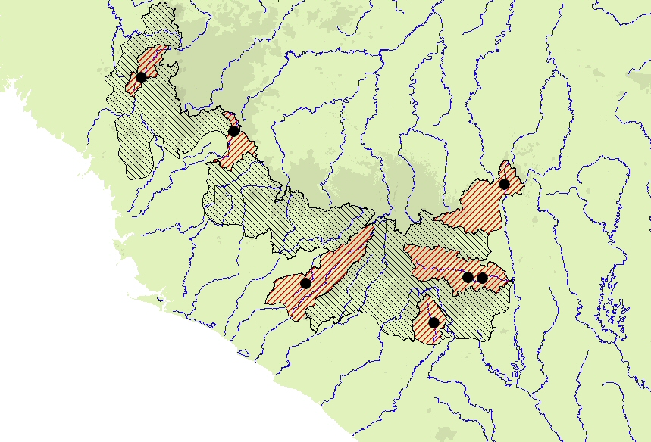

There are three methods for producing the species distribution maps
- Using GIS (the preferred method)
- Excel spreadsheet of point localities (We convert the points to maps)
- Hand drawn maps (the last resort!)

Using GIS

Using GIS software is the preferred method. There are various GIS applications that can be used to achieve the same goals but the most common is ESRI ArcGIS. This document assumes you have a basic understanding of how to use ArcMap. Links to the excellent online help pages are provided where necessary. The steps are also explained in a generic way so they can be followed using other GIS applications.
The methodology essentially involves adding a hydroshed layer and detailed river layer to your map. It is a good idea to clip these layers to your study region to reduce processing time and file size. You will also need to add your known location points and then perform an intersect with the hydroshed layer to produce the Extant (known) basins. Expert knowledge is then used to decipher and select the probably extant (inferred) basins. Further processing such as redefining the range to take into account environment factors such as elevation is possible as well as buffering around rivers and estuaries.
The following outlines the basic steps.

- Import Global Hydrosheds layer and detailed river dataset (clip to local area).
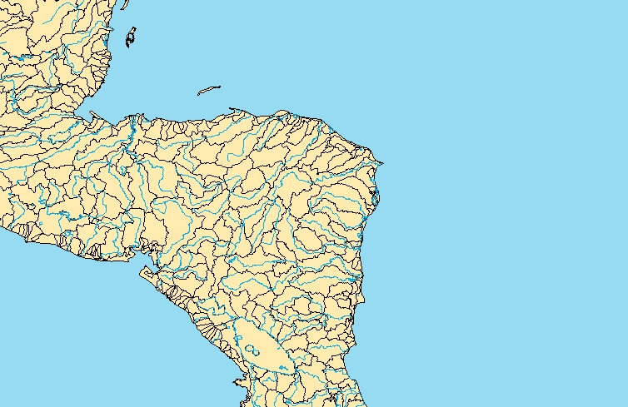

- Import known location point data. You can easily convert points in a spreadsheet to a point layer by using the Add XY Data option in the Tools menu. Simply select your excel spreadsheet and the X and Y columns.

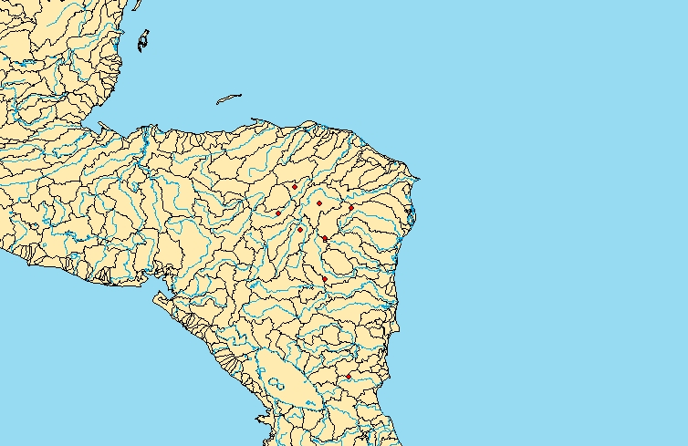

- Select hydrosheds that intersect with the points. Use select by location from the selection menu.
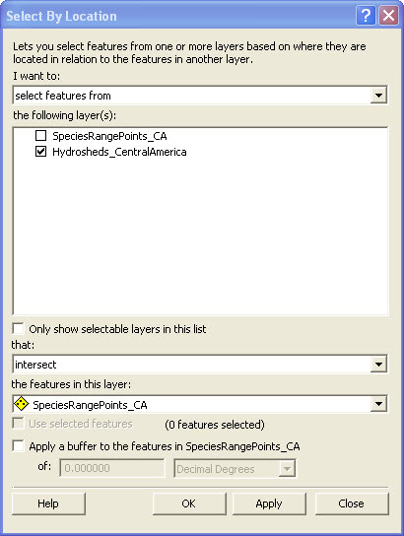

- Export the selected hydrosheds to a shapefile by right clicking on the hydroshed layer and using the Export Data option

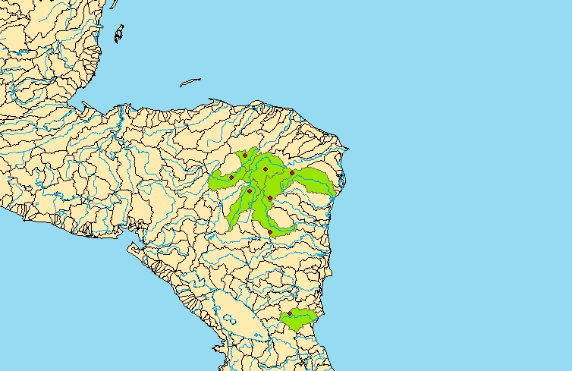

- Use expert opinion and published data to define probably extant (inferred) basins. Use the select tool to select the hydrosheds then export using Export Data
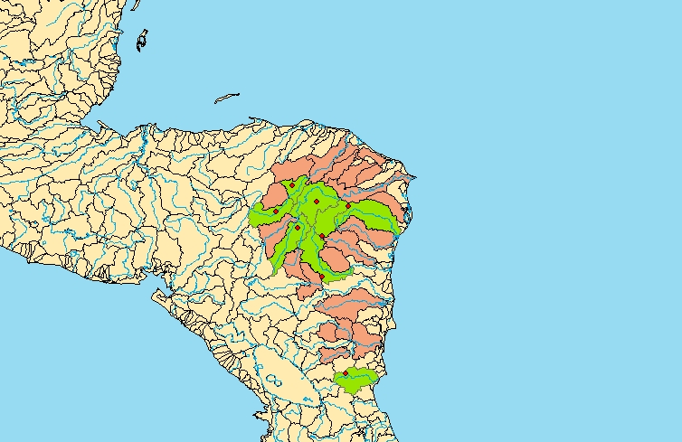

- If the information is available the basins can be further defined based on altitude, stream order , habitat etc
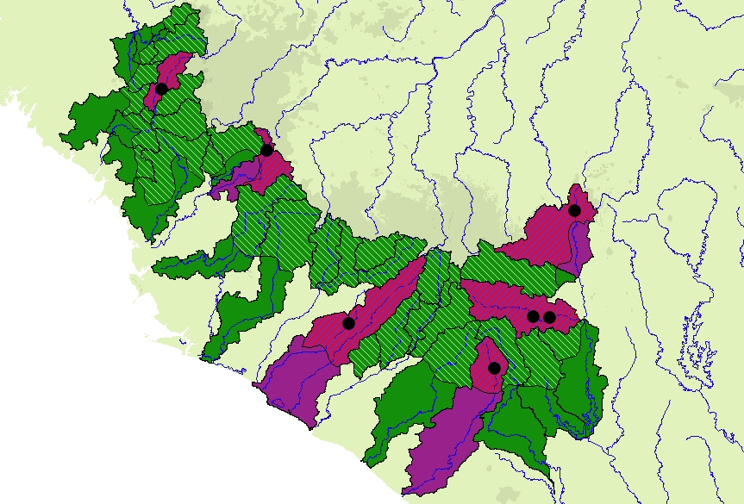

- For species found only in a main river channel and not in the tributaries, we use a 10km buffer (20km in width). Use the buffer tool in ArcMap.
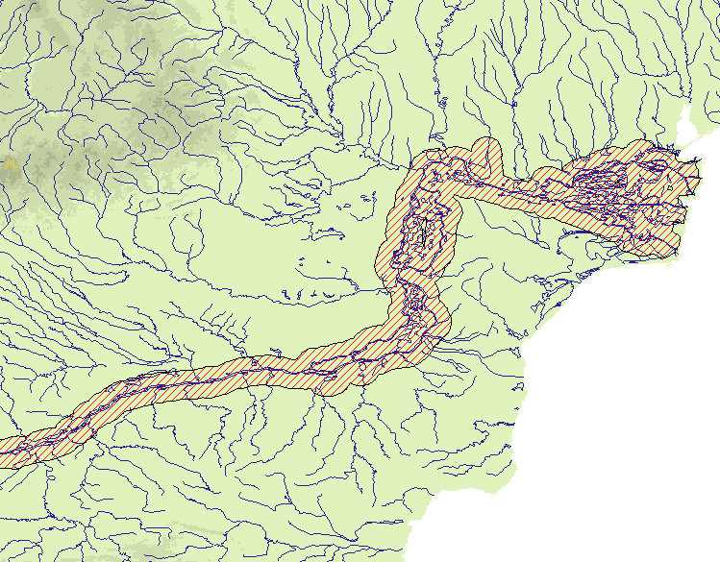

- For species only found in brackish water, estuaries and costal lagoons, we add a 10km buffer (10 km in width).
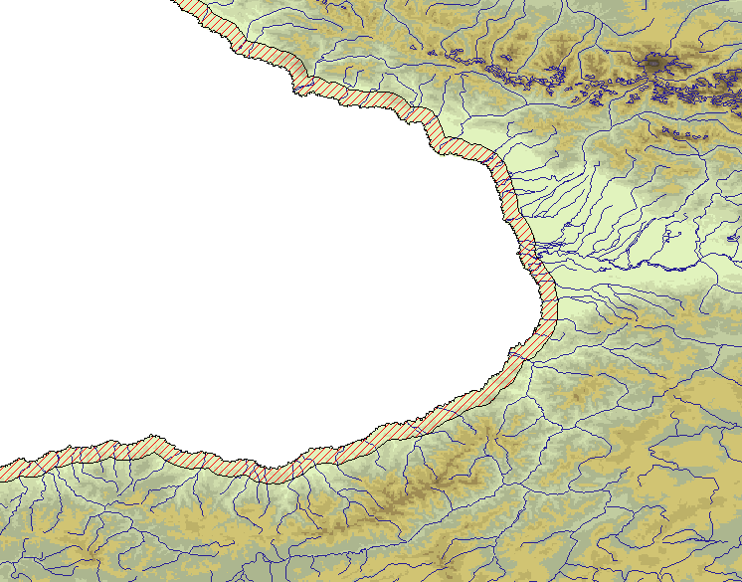
Example map for a Southern Africa crab assessment
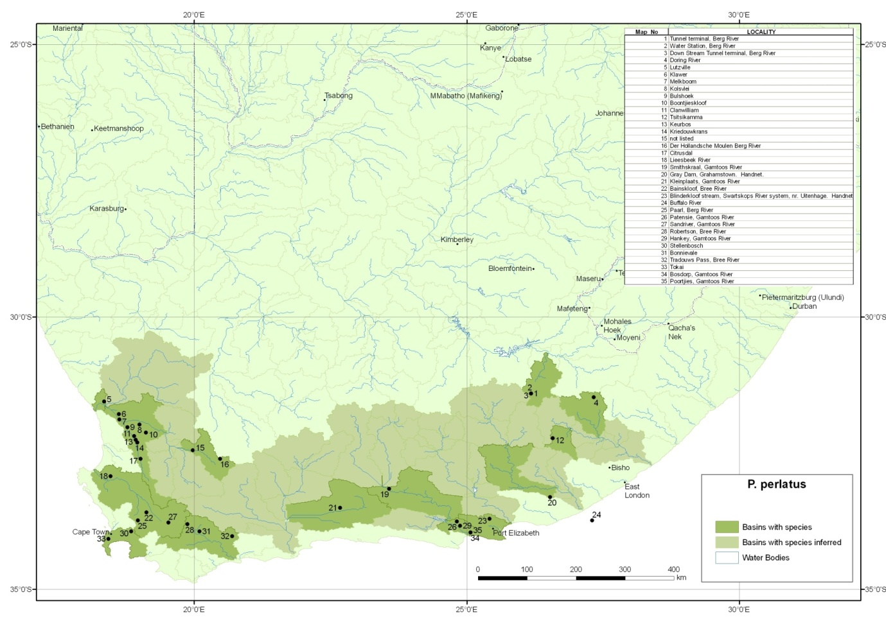

GIS Attribute Standards

The Hydroshed layer that is used for mapping contains a number of fields that need to be completed before the data is returned to IUCN. The following lists these field and explains what they need to contain.

Basin Attributes
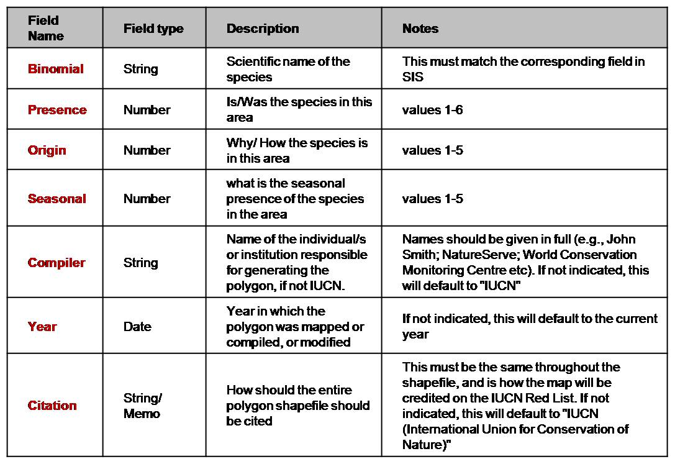

Point Attributes
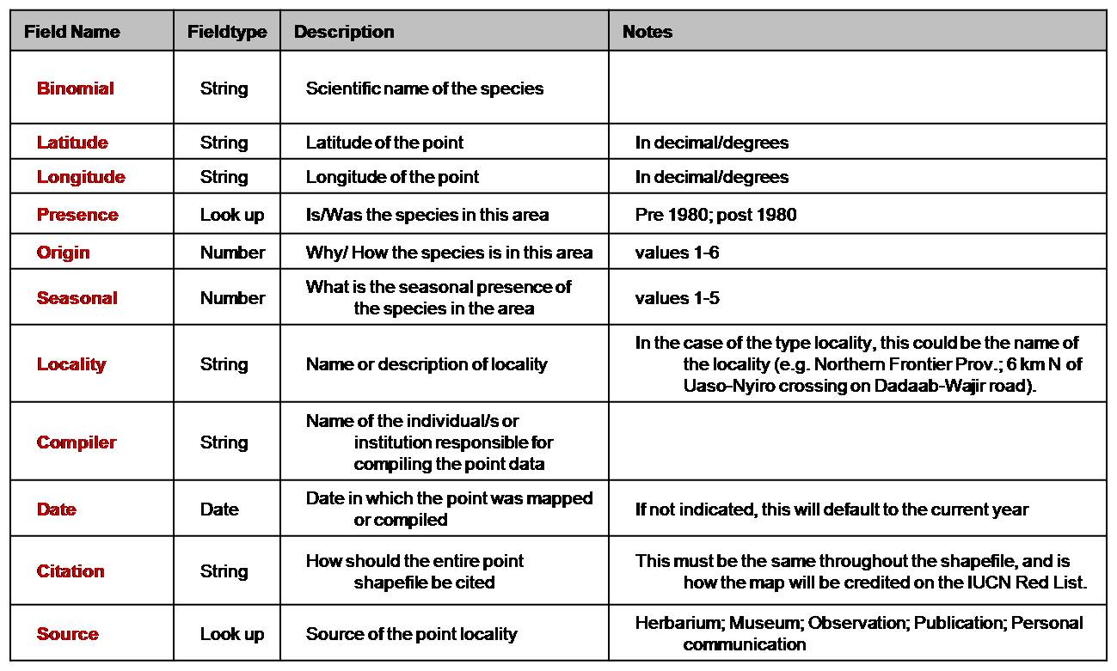
Codes
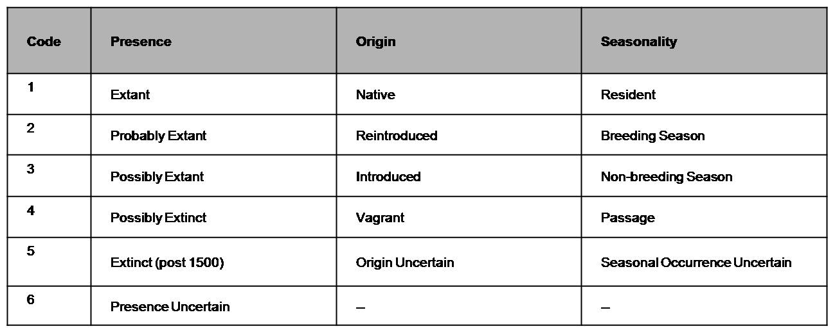
Code Definitions

Extant – The species is known or thought very likely to occur presently in the area, usually
encompassing current or recent (post 1980) localities where suitable habitat at appropriate
altitudes remains.
Probably Extant – The species’ presence is considered probable, either based on extrapolations
of known records, or realistic inferences (e.g., based on distribution of suitable habitat at
appropriate altitudes and proximity to areas where it is known or thought very likely to remain
Extant). ‘Probably Extant’ ranges often extend beyond areas where the species is Extant, or may
fall between them.
Possibly Extant: The species may possibly occur, and should be searched for, but there are no
known records and less than probably occurrence. ‘Possibly Extant’ ranges often extend beyond
areas where the species is Extant (q.v.) or Probably Extant (q.v.), or may fall between them.
Possibly Extinct – The species was formerly known or thought very likely to occur in the area,
but it is most likely now extirpated from the area because habitat loss/other threats are thought
likely to have extirpated the species and/or owing to a lack of records in the last 30 years.
Extinct – The species was formerly known or thought very likely to occur in the area, but there
have been no records in the last 30 years and it is almost certain that the species no longer
occurs, and/or habitat loss/other threats have almost certainly extirpated the species.
Presence Uncertain – The species was formerly known or thought very likely to occur in the
area but it is no longer known whether it still occurs (usually because there have been no recent
surveys).
Notes:
1. These codes are mutually exclusive; a polygon coded as “Extant” cannot also be coded as
“Extinct”.
2. To obtain the total historical range of a species, one would sum polygons for Extant,
Probably Extant, Possibly Extinct, Extinct and Presence Uncertain, but not Possibly Extant.
Native – The species is/was native to the area
Reintroduced - The species is/was reintroduced through either direct or indirect human activity.
Introduced – The species is/was introduced outside of its historical distribution range through
either direct or indirect human activity.
Vagrant – The species is/was recorded once or sporadically, but it is known not to be native to
the area.
Origin Uncertain - The species’ provenance in an area is not known (it may be native,
reintroduced or introduced)
1.Notes:
1. These codes are mutually exclusive; a polygon coded as “Native” cannot also be coded as
“Introduced”.

Resident – the species is/was known or thought very likely to be resident throughout the year
Breeding Season – The species is/was known or thought very likely to occur regularly during the
breeding season and to breed.
Non-breeding Season – The species is/was known or thought very likely to occur regularly
during the non-breeding season. In the Eurasian and North American contexts, this encompasses
‘winter’.
Passage – The species is/was known or thought very likely to occur regularly during a relatively
short period(s) of the year on migration between breeding and non-breeding ranges.
Seasonal Occurrence Uncertain – The species is/was present, but it is not known if it is present
during part or all of the year.
Metadata Reference Information
14. Metadata Date:
Sep 2010
15. Most recent Update:
Sep 2010

Point localities – Excel spreadsheet

Not everyone has access to GIS software. You can send IUCN point data in spreadsheet format.
IUCN will convert the data into maps. You can then draw the inferred range onto these maps. You can download a point locality template here.
Important:
Latitude & Longitude in Decimal Degrees NOT Degrees Minutes and seconds.

Hand Drawn Maps

This is a last resort!
Blank maps for your region can be provided. Print them out and draw around the basins where the species is found.
These maps can then be digitised.

